EMPLOYEE ANALYTICS DASHBOARD FOR HR DEPARTMENT

By

Shyamashree Ghorai (STB03-T0007)

Under Supervision of

Miss. Urooj Khan, Data Scientist

Scifor Technologies,

Bangalore

(Duration: 11 Oct 2023 to 15 Feb 2024)



TABLE OF CONTENTS
DECLARATION
CERTIFICATE
ACKNOWLEDGEMENTS
ABSTRACT
CHAPTER 1
CHAPTER 2
CHAPTER 3
CHAPTER 4
CHAPTER 5
APPENDIX A
APPENDIX B
REFERENCES

DECLARATION
I, Shyamashree Ghorai, hereby declare that presented report for the internship titled “Employee Analytics Dashboard for HR Department” at Scifor Technologies is uniquely prepared by me after the completion the completion of four months’ work at Scifor Technologies.

Signature……Shyamashree Ghorai………………………

Name……Shyamashree Ghorai……………………………

Roll No…………STB03-T007……………………

Date………06.02.2024…………………………

CERTIFICATE

This is to certify that the Project Report entitled Employee Analytics Dashboard for HR Department which is submitted by Shyamashree Ghorai (STB03-T0007) is a record of the candidate own work carried out by her under my supervision. The matter embodied in this work is original and has not been submitted for the award of any other work.

Miss. Urooj Khan
Supervisor

ACKNOWLEDGEMENT

It gives us a great sense of pleasure to present the report of the Internship Project undertaken during internship at Scifor Technologies.I have taken efforts in this project. However, it would not have been possible without the kind support and help of many individuals and organizations. I would like to extend my sincere thanks to all of them.
I am highly indebted to Miss. Urooj Khan for guidance and constant supervision as well as providing necessary information regarding the project and also for the support of completing the project.
I would like to express my special gratitude and thanks to industry persons for giving me such attention and time.
.

Signature…Shyamashree Ghorai………………………….

Name………Shyamashree Ghorai…………………………

Roll No………STB03-T0007………………………

Date……06.02.2024……………………………

Abstract
As organizations strive to make informed decisions, Employee Analytics Dashboard for HR Department has become a critical tool for measuring workforce performance. This HR analytics dashboard, built using Power BI, offers a comprehensive view of key metrics that help organizations to identify and address HR-related challenges. It provides organizations with the necessary insights to make data-driven decisions and gain a competitive edge in today's dynamic business environment.

Initially, Data was very messy and unclean, so we used external tools to make it ready for the Visualization. Data cleaning has been done using Power BI.

CHAPTER 1
INTRODUCTION
An Employee Analytics Dashboard for HR Department is a business intelligence tool that allows Human Resource team to analyse and visualize data to organization’s workforce. Employees are the most important asset within an organization. Employee performance dashboard help HR teams and business managers understand the effectiveness, satisfaction and goal progress of their workforce. Using an interactive dashboard, HR professionals can dig deeper into demographic data.

Motivation

An Employee Analytics Dashboard for HR Department can provide numerous benefits to any organization. By visualizing and analysing data on the organization’s human capital, organization’s team can make more informed decisions, enhance efficiency, increase employee engagement, and reduce risk. By leveraging the insights provided by an Employee Analytics Dashboard for HR Department, company’s HR team can help the company build a strong, high-performing workforce. Some benefits having Employee Analytics Dashboard for HR Department:
- Improved decision making
- Enhanced efficiency
- Increased employee engagement
- Improved performance management
- Enhanced talent management
- Reduced risk
- Increased transparency

Problem Statement

Over 2.5 quintillion bytes of data are created every single day. Businesses have to be able to process this data in order to make informed decisions while increasing profits. Being able to use any analytics platform is necessary with the rise in demand in the market. The visual analytics platform enables users to solve problems through data analysis. Power BI remain one of the most popular tools available today. Using Power BI databases and spreadsheets, complicated information can be made comprehensible by ordinary people.

Objective

Employee analytics, also referred to as people analytics, workforce analytics, or talent analytics, involves gathering together, analysing, and reporting HR data. It enables an organization to measure the impact of a range of HR metrics on overall business performance and make decisions based on data.

Valuable inputs from across the organization will help to guide analytics deployment and future state—including the roles, responsibilities, architecture, and processes, as well as the success measurements to understand progress. After completing. we should have a greater sense of the direction we are headed with our analytics strategy by defining your vision for the use of data, identifying strategic initiatives and KPIs

Power BI is easy to use, it is more feasible and flexible to create a dashboard on it because of its premier features. Some of its features are listed below. Depending upon the useability of Power BI it has the following features:

- Easy to access from different sources,

- No need for any technical or programming knowledge, and

- Quick response for making a dashboard

CHAPTER 2
Proposed method

Our Proposed system will be using Power BI. Using Power BI databases and spreadsheets, complicated information can be made comprehensible by ordinary people. In addition, data can be better visualized and understood with Power BI. we can analyse the data to discover key understanding.

Output
O

- Firstly, I displayed some Key Performance Indicators (KPIs).

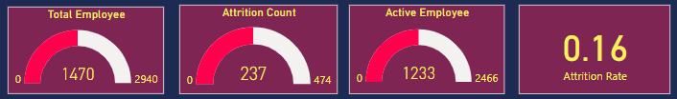

- I create a bar chart for finding active employee and attrition count based upon the department. From chart, major part of active employee from R&D department.

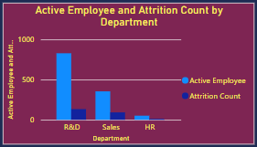

- I create a bar chart for active employee for different job role. Major part of active employee are of job role sales executive, research scientist and laboratory technician.

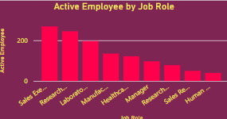

- I create a donut chart for finding performance rating based upon different job role. Sales executive has the highest performance rating.

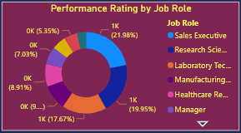

Conclusion

In this project, Employee Analytics Dashboard for HR Department allows HR professionals to analyze and visualize data to organization’s workforce.
By using Power BI which provides interactive data visualization and business intelligence software that lets you explore, visualize, and share data securely
The report allows leadership to take appropriate action, whether that is disciplinary measures, mediation, policy changes, or closing the matter.

